ENG 12 | WRITING PROJECT: THE INTERIVEWS

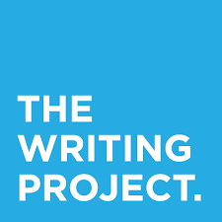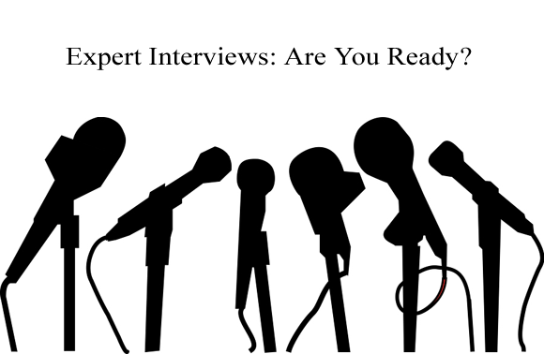

DUE DATE TIMELINE:

 | INTERVIEW PROCES GRADE | DUE DATE | HOW TO TURN IT IN | GRADED HOW?
 | Interview Questions Developed | DUE DEC 15 | Hardcopy in class  (see form attached) | CLASSWORK GRADE
 | Initial Contact & Interview Date/Time Scheduled | DUE DEC 21 | Hardcopy in class  (see form attached) | ASSESSMENT GRADE  Completion Grade
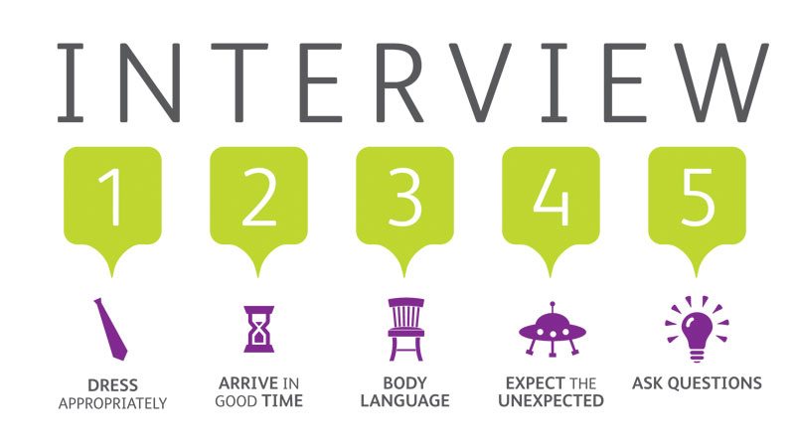 | Interview Conducted/  Finished | DUE JAN 11 | - Hardcopy email exchange OR  - Phone Recording MP3 emailed to Ahearn  OR  - Video emailed to Ahearn | ASSESSMENT GRADE  Completion Grade
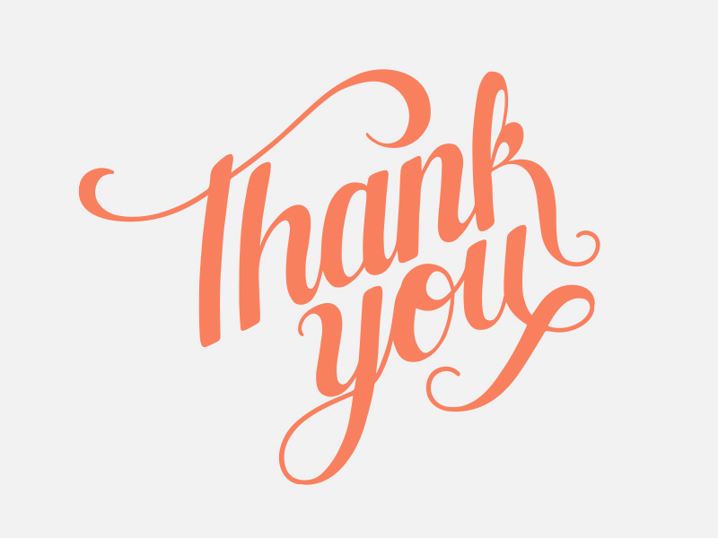 | Thank You  Note | 1 week after your interview. | Turn stamped & addressed thank you card in to Ahearn. She will mail it out. | HOMEWORK GRADE  Completion Grade

WP: Interview Questions Developed

This hardcopy form is DUE DEC 15

YOUR TOPIC (Career or Major or Field of Study):

THE ISSUE OR PROBLEM IN YOUR FIELD YOU WILL RESEARCH:

YOUR SATND ON THE ISSUE (what do YOU think about the issue? What side are you on?):

THESIS:

INTERVIEW QUESTIONS
- You need 10 questions minimum.
- Your interview should not be longer than 15 minutes of conversation, so keep your questions focused on the main point---the problem or issue in your field.
- Your questions should move from general to specific, for example, “What made you want to become a doctor?” to a more specific question like “What do you do in your everyday work life that helps to lower the death rate for cancer patients?”
- Make sure your questions drill down into the Problem or Issue in your field that you’re researching.
- Be prepared to ask organic questions as they arise in your conversation.

MY QUESTIONS TO ASK MY INTERVIEWER

WP: Initial Contact & Interview Date/Time Scheduled

This hardcopy form is DUE DEC 21

WHO WILL YOU INTERVIEW?
WHEN?

HOW WILL YOU RECORD THE INTERVIEW?
- Email exchange
- Phone interview –record the conversation
- Set up a video recording for the interview
- Skype/Video Chat recording

WP: Interview Conducted & Finished

Email to Ahearn DUE JAN 11
- Hardcopy email exchange OR
- Phone Audio Recording MP3 emailed to Ahearn OR
- Video emailed to Ahearn




Interview Rubric
1-25 points | Was the interviewee appropriate to the writing topic/problem or issue?
1-25 points | Presentation skills
1-25 points | Were the questions appropriate to the writing topic/problem or issue?
1-25 points | Were you organized and prepared?

TOTAL: ______/100 Assessment Points

WP: Interview Conducted & Finished

Email to Ahearn DUE JAN 18

DUE ONE WEEK AFTER YOURINTERVIEW

Turn stamped & addressed thank you card in to Ahearn. She will mail it out.

FREQUENTLY ASKED QUSTIONS: THANK YOU NOTES TO INTERVIEWEES
Q: When are thank you notes appropriate?
A: Thank you notes are never inappropriate. You should always send a thank you note after interviewing someone or being interviewed for a job, internship, or volunteer opportunity. Thank you letters should be brief and sent as soon as possible after your interview.
Q: When should I send a thank you note?
A: Send the note as soon as possible after the interview – waiting too long almost negates the purpose.
Q: Do I write a handwritten note, an email or a typed letter?
A: The form your thank you note should take really depends on your style and relationship with the interviewee. Generally, thank you letters should be word processed on 8 1/2" x 11" heavy bond paper and should follow proper business format. Some feel that a thank you note sent via e-mail is sufficient, while others feel that a letter sent through snail mail is more appropriate. You may also choose to handwrite a thank you on note cards if you know the interviewee personally, but should probably only do so if your handwriting is neat and legible.
No matter what form you choose to send the note in, there are three must-dos in every thank you note:
- Personalize the note: Be specific in the note and mention a topic that you spoke with your interviewer about. Make sure that if you send multiple notes to different attorneys with the same employer each note does not sound the same;
- Double check that all names are spelled correctly;
- Check that there are no other misspellings or errors.

SAMPLE THANK YOU NOTES
1. Thank You Letter After An Interview
November 19, 2007
John Smith, Esq.
Committee for Public Counsel Services Public Defender Division
44 Bromfield St.
Boston, MA 02110
Dear Mr. Smith:
Thank you very much for taking your time to allow me to interview you yesterday. Your insight into the {insert your topic here} ongoing experience of being a new attorney at Smith Jones was very helpful.
I enjoyed hearing your thoughts on {insert your topic here} the recent IP issues I have been following in the news. You are clearly enthusiastic about your work and it was encouraging to hear about {insert your topic here} the diverse opportunities available at Smith Jones. I believe that {insert your chosen career filed or major here} is a great fit for me and our meeting confirmed my desire to become part of {insert your topic here} the Smith Jones team.
It was a pleasure to meet you. {insert your own connection to the interviewee here}I will be rooting for your Huskies on Saturday!
Sincerely,
David Jones

2. Thank You Email After An Interview
From: Jane Smith
Sent: Tuesday, September 18, 2007 To: David Jones
Subject: Thank you
Dear Mr. Soandso:
Thank you for taking the time to meet with me yesterday. I enjoyed hearing about the {insert your topic here} exciting developments in your recent lobbying effort at the Massachusetts State House. I had a great experience during my co-op at GBLS and am excited about the prospect of working with you again after graduation. Please feel free to contact me if you need any additional information. I look forward to hearing from you.
Sincerely,
Jane Smith

3. Thank You E-Mail After An Informational Interview
From: Jane Smith
Sent: Tuesday, September 18, 2007 To: Mary Jones
Subject: Thank you
Dear Ms. Jones:
Thank you for taking the time to speak with me today. I enjoyed hearing about your experiences as {insert your topic here} an advocate for survivors of domestic violence. It sounds like a challenging, but rewarding career. I greatly appreciated your advice on how to meet other professionals working in this field. At your suggestion, I registered for the Women in Public Interest Law conference in Boston next month. I will be sure to keep you informed of my progress. Please do not hesitate to contact me if you think of any additional suggestions.
Thank you again for meeting with me. I really gained a lot from our conversation.
Sincerely,
Jane Smith

