ENG 12 | WRITING PROJECT

INTRODUCTIORY SECTION

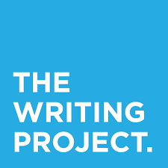

- Now that your research is done, complete the introductory section of your research paper in your GOOGLE DOC and re-share with Ms. Ahearn.

ENGLISH 12 RESEARCH PAPER INTRODUCTORY SECTION OUTLINE

- INTRODUCTION PARAGRAPH 1
- Opener (use an anecdote, a controversial statement, a quote from an expert, or a shocking statistic to open your paper).
- State your topic (ex., this paper will examine (your topic)…)

- INTRODUCTION PARAGRAPH 2
- State why you are interested in this topic (10-20 sentences about why you chose your career/field).

- INTRODUCTION PARAGRAPH 3
- State the obstacles or challenges you can foresee for you to becoming your chosen career (5-8 sentences)

- INTRODUCTION PARAGRAPH 4
- State the initial problem or issue in your field that you used to guide your research.
- Summarize one side of the debate; what some experts say is the solution to the problem or issue in your field.
- Summarize the OTHER SIDE of the debate; what other experts say is the solution to the problem or issue in your field.
- State your thesis/hypothesis. What do you think your research will show? What do you think the solution to the problem or issue in your field will be?

