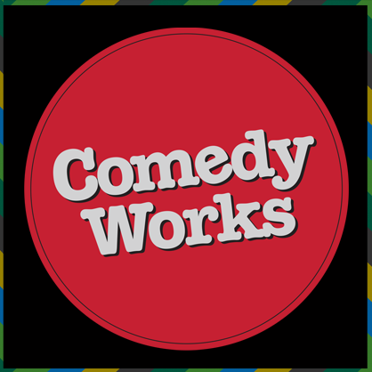
QUARTER 2 COMEDY:
A Comedy or Satire of Your Choice

You will each read a comedy or satire of your choice this quarter. You will complete the reading at home individually and come to class prepared with an Animoto (a movie trailer or digital ad) to present to the class.

Assignment | Your assignment is to read your chosen comedy or satire and create an
- ANIMOTO http://animoto.com The idea is that you should create a "movie trailer" for your chosen comedy/satire. Try to hook your reader and "sell" them your work. Try to get us to see why the work was funny, i.e., include the best joke or try to put the tone of the work across. Be creative. Let the work’s comedic genius guide your visual representation of the book. Have fun!

PLEASE feel free to contact me if you have any questions or concerns. Molly.ahearn@pgcps.org

FINAL PROJECT RUBRIC

CATEGORY | 5 | 3 | 2 | 1
Content | Covers topic in-depth with details and examples. Knowledge of the text is excellent. | Includes essential knowledge about the topic. Knowledge of the text appears to be good. | Includes essential information about the topic but there are 1-2 factual errors. | Content is minimal OR there are several factual errors.
Originality | Project shows a large amount of original thought. Ideas are creative and inventive. | Project shows some original thought. Work shows new ideas and insights. | Uses other people's ideas (giving them credit), but there is little evidence of original thinking. | Uses other people's ideas, but does not give them credit.
Following  Directions | Student chose a project, completing all necessary requirements. |  |  | Student did not follow directions.
Attractiveness | Makes excellent use of font, color, graphics, effects, etc. to enhance the project. | Makes good use of font, color, graphics, effects, etc. to enhance to project. | Makes use of font, color, graphics, effects, etc. but occasionally these detract from the project | Unattractive.
Effort | Final project shows students put a lot of time and effort into the assignment. | Final project shows some effort was put forth. | Final project shows minimal effort. | Little to no effort is apparent.
Mechanics | No misspellings or grammatical errors. | Three or fewer misspellings and/or mechanical errors. | Four misspellings and/or grammatical errors. | More than 4 errors in spelling or grammar.
Presentation  (extra credit) | Well-rehearsed with smooth delivery that holds audience attention. | Rehearsed with fairly smooth delivery that holds audience attention most of the time. | Delivery not smooth, but able to maintain interest of the audience most of the time. | Delivery not smooth and audience attention often lost.

30 points total with a possible 5 points for extra credit.

