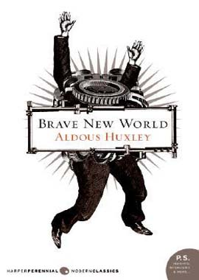
BRAVE NEW WORLD by Aldous Huxley
Aldous Huxley's BRAVE NEW WORLD is part of an unforgettable trilogy of masterpieces which are strictly connected each to the other. The other two novels are 1984 by George Orwell and Ray Bradbury's FAHRENHEIT 451. They are all science fiction dystopian novels, not my favourite genre, but the three of them left an indelible mark inside me. There is science fiction and science fiction. These three novels are amazingly interesting and frighteningly premonitory.

They all imagine life in a dystopian society, under totalitarian regimes, in which human beings are dehumanized and totally deprived of their freedom.

In Brave New World , set in the future year A. F . 632 ( 632 years after the advent of the American magnate Henry Ford), the stability of the World State is maintained through a combination of biological engineering and exhaustive conditioning. The citizens have not been born but "hatched" to fill their predestined social roles. In infancy the virtues of passive obedience, material consumption and mindless promiscuity are inculcated upon them by means of hypnopedia or sleep - teaching. In later life the citizens of the World State are given free handouts of soma , the Government - approved dope. The World State's motto is: "Community, Identity, Stability". The World State is divided into ten zones, each run by a Resident World Controller. "His fordshisp", Mustapha Mond, the controller of the Western European Zone centred in London, heads a hierarchical, factory-like concern with a mass of Epsilon- Minus Semi - Moron bred for menial labour at the base and with castes of increasing ability ranked above them. Immediately below Mond there are a caste of Alpha- Plus intellectuals. Bernard Marx and Helmhotz Watson are members of this elite, but both have developed subversive tendencies, taking delight in such deviant pleasures as being alone and abstaining from sex.
The only other human beings permitted to exist beyond the pale of the World State are the inhabitants of the various Savage Reservations. Segregated by electrified fences from the Fordian hell which surrounds them, the savages still get married, make love, give birth and die as of old. It is while visiting the Reservation in New Mexico that Bernard Marx meets a savage named John, whom he brings to London. John's disruptive presence in London will give the reader the possibility to share his perspective of that full totalitarian horror of AF. 632.

READING SCHEDULE
** Reading Room Posts for each Questions Set are due on each DUE DATE.
CHAPTERS | QUESTION SET | DUE DATE
1-3 | Set 1 | February 7, 2017**
4-6 | Set 2 | February 14, 2017**
7-9 | Set 3 | February 21, 2017**
10-12 | Set 4 | February 27, 2017**
13-15 | Set 5 | March 7, 2017**
16-18 | Set 6 | March 13, 2017**
Follow Up Questions | Set 7 | March 21, 2017**

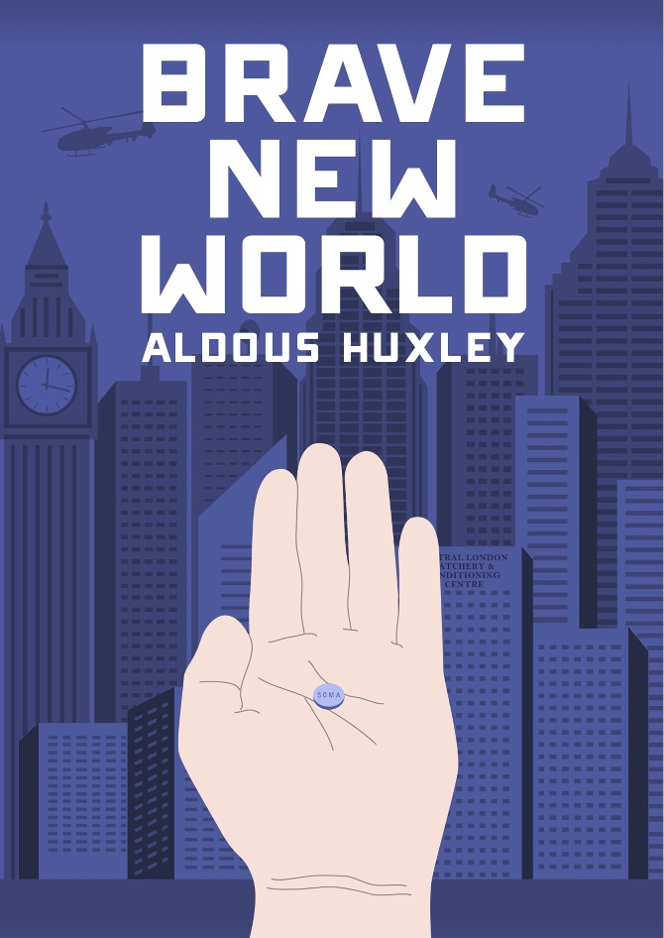
QUESTION SET 1

BRAVE NEW WORLD by Aldous Huxley

Chapter 1
1. Why is the first sentence strange? What does it set up?
2. What is the meaning of the World State’s motto “COMMUNITY, IDENTITY, STABILITY?”
3. Why does the fertilizing room look so cold, when it is actually hot inside? What goes on there?
4. Why do particulars “make for virtue and happiness,” while generalities “are intellectually necessary evils?”
5. How do people know who they are in this society?
6. Why use the Bokanovsky process at all? How is it an instrument “of social stability?”
7. Why don’t the Epsilons “need human intelligence?”

Chapter 2
1. What work does the conditioning do? Who gets conditioned? How does hypnopaedia work?
2. Why condition the Deltas to hate nature but love outdoor sports?
3. How does time work in this book? History? Why does Ford say “History is Bunk?”
4. What are the various castes like, and why?
5. How do the students demonstrate their own conditioning?

Chapter 3
1. How do the children play together? What is childhood like?
2. How is our world depicted? How do we get from here to there?
3. Why must games be so complex in this society?
4. Why are strong emotions dangerous? Family relationships? Romance? Religion? Art? Culture?
5. How is sexuality used in this novel? Do you see any problems with it?
6. What does Mustapha Mond do? What is his relationship to history?
7. Is there anything unusual about Lenina Crowne? Bernard Marx? What? Why?
8. How does Huxley use the cinematic technique toward the end of this chapter?
9. What is soma? What are its uses?
10. How do people age in this society?

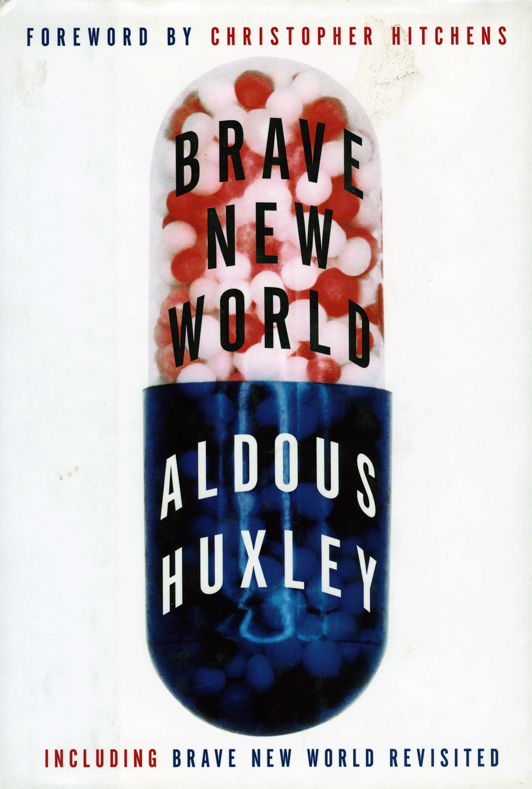
QUESTION SET 2

BRAVE NEW WORLD by Aldous Huxley

Chapter 4
1. What is life like for the Epsilon-Minus Semi-Moron who runs the elevator?
2. How do the other Alphas relate to Bernard?
3. What does Lenina do on her date?
4. What does she think of the lower castes?
5. Why is Bernard the way he is? What does he really want?
6. Why is Helmholtz the way he is? What does he want? How is he different from Bernard?

Chapter 5
1. What do Lenina and Henry talk about on their way home? What happens at the crematorium?
2. Why are stars depressing?
3. What are the solidarity services like? What role do they play? How does Bernard fit?

Chapter 6
1. Why is being alone a bad thing?
2. What do Lenina and Bernard do on their first date? Why is the ocean important? The moon?
3. What does Bernard say about freedom? What does he mean?
4. How does the date end?
5. What does it mean to be infantile in this society?
6. How does the director feel about Bernard? Why is he warning him?
7. What does his story mean? What does it show us about him?
8. How does Helmholtz feel about Bernard after he hears the story of the meeting with the director?
9. What do we learn from the Warden? What are the reservations like?
10. What does the word Malpais mean?

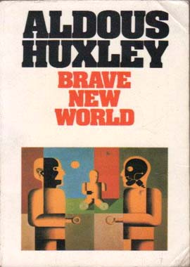
QUESTION SET 3

BRAVE NEW WORLD by Aldous Huxley

Chapter 7
1. How is the mesa like a ship?
2. Why doesn’t Lenina like their Indian guide?
3. What is the city itself like? What are the people like? How does Lenina respond? Bernard?
4. What ceremony do the witness? What does it mean? What does it seem like to Lenina?
5. What idols emerge from the ground?
6. How is John Savage different? What does he want? How does he respond to Lenina?
7. What is Linda’s story? What has her life been like here? How does Linda react to her?

Chapter 8
1. What was John’s upbringing like? His relationship with Linda? His education?
2. Why doesn’t linda want to be called a mother?
3. What social positions do Linda and John hold in Malpais?
4. What does John want in his life?
5. What does Linda tell him about the Other Place?
6. What does he learn from Shakespeare? How does he relate to Hamlet? The Tempest?
7. What does it mean to discover “Time and Death and God?”
8. What do John and Bernard have in common?
9. Why does Bernard want to take John to London?

Chapter 9
1, Why does Mustapha Mond agree to the plan?
2. What happens when John watches Lenina sleep? What does he think or feel?

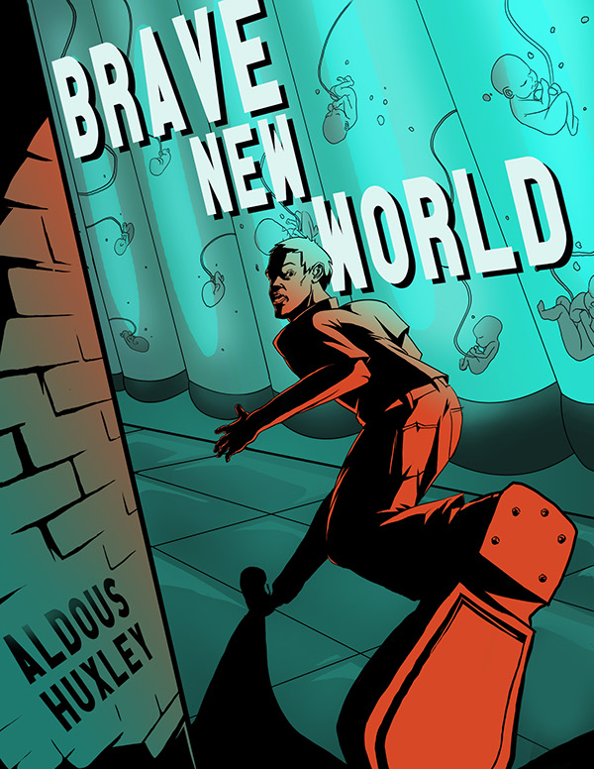
QUESTION SET 4

BRAVE NEW WORLD by Aldous Huxley

Chapter 10
1. How and why was the DHC planing to make an example out of Bernard?
2. Why is unorthodoxy worse than murder?
3. How does Linda act in the hatchery? How does the DHC react? The spectators?

Chapter 11
1. Why does John become popular, but not Linda?
2. How does Bernard’s life change? How does he react? What does Helmholtz think?
3. How does Linda spend her time?
4. How does Bernard talk in public?
5. What does Mustapha Mond think of Bernard’s reports?
6. What does John think of the caste system? Of the clones? How does he use The Tempest now?
7. What do we learn about the reservations at Eton? What does John think?
8. How do the children respond to dying? Why?
9. How does Lenina feel about John?
10. What does John think about the feelies? Why?

Chapter 12
1. Why does John decide not to come to Bernard’s party? What does this mean for Bernard?
2. How does Lenina feel at the party? Why does she feel this way?
3. How does John feel? Why is he reading Romeo and Juliet?
4. What does it mean that Lenina likes looking at the moon now?
5. What role does Mustapha Mond play as a censor? Why des he do it? What does he censor? What does he really want?
6. How does Bernard’s position change? How do John and Helmholtz respond to Bernard now?
7. Why is Helmholtz in trouble with the authorities? What has he done that is dangerous, and why is it dangerous? Why did he do it? What does he want?
8. What does Helmholtz think of Shakespeare? Romeo and Juliet?
9. What does Helmholtz think is necessary for good writing?

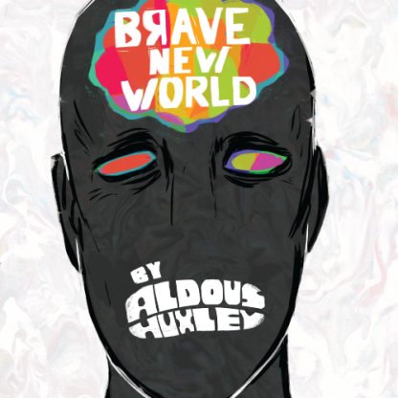
QUESTION SET 5

BRAVE NEW WORLD by Aldous Huxley

Chapter 13
1. What are the consequences of Lenina’s emotion? What is happening?
2. How does she feel for John? What does she do to get what she wants?
3. How does John feel for Lenina? What does he want to do to prove it?
3. How does John react to Lenina’s actions? Why does he respond this way? What did he want from her?

Chapter 14
1. What is the hospital for the dying like? What are the dying like?
2. Note the television. Recall TV did not exist as we know it in 1932.
3. Why is Linda dying?
4. What memories flood over John as he stands before his mother? Why these particular memories? What are his memories of the “other place”? What role does memory play in civilization?
5. Why are the Delta children at the hospital? What does John think of this?
6. Why isn’t death terrible for those in the civilized world? What does this mean for the individual?

Chapter 15
1. The title phrase recurs here. How is it used differently than before? What does it mean now?
2. Why does John decide to interfere with the soma distribution? Why does he say it is poison?
3. What is John’s conception of slavery and freedom? Manhood? Liberty?
4. What does he think of the Deltas to whom he delivers his speech?
5. What roles do Bernard and Helmholtz play here? What does this tell us about their characters?
6. How does the soma riot end? What does it mean to be happy and good?

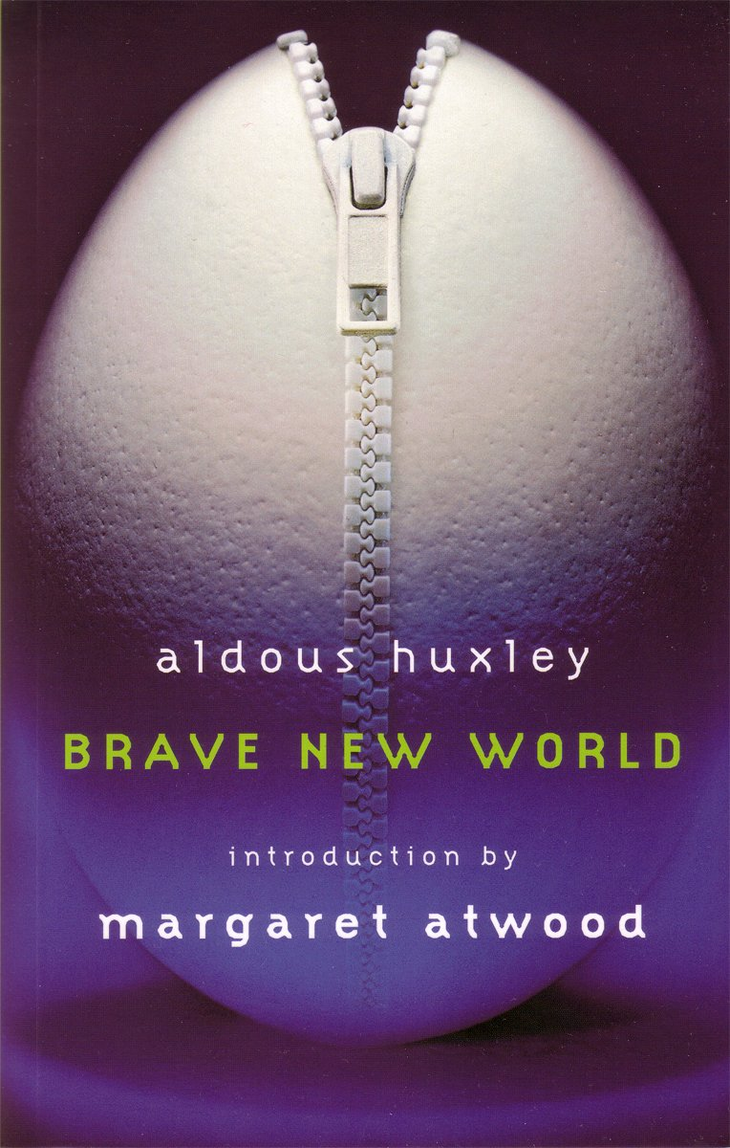
QUESTION SET 6

BRAVE NEW WORLD by Aldous Huxley

Chapter 16
1. How would you describe Bernard’s behavior in this chapter? Why does he act this way?
2. Why doesn’t John like civilization?
3. Why does Mond say old and beautiful things are forbidden?
4. Why can’t tragedies be written now? What is necessary for tragedy?
5. What does art mean in the new world? What can’t it mean? What is Helmholtz’s role?
6. What does Mond say is the role of liberty? Happiness? Stability? Truth and Beauty?
7. How does Mond explain the caste system? Do you agree?
8. What would happen with an entire society of Alphas?
9. Why must science be constrained? Progress? Do you agree?
10. What choice did Mond make as a young physicist? Why? What is his real position?
11. Why does Helmholtz make the choice he makes?

Chapter 17
1. Why does Mond want to talk with John alone? What do they talk about?
2. What is the significance of their discussion of religion? What does John argue religion can give to civilization? Why does Mond argue that it is unnecessary and potentially dangerous?
3. What does Mond believe is the role of God? How is it related to the self?
4. What role does solitude play in spirituality?
5. How does John argue that the civilized man has been degraded? From what and to what?
6. What are your conceptions of the roles of self-denial, chastity, nobility, heroism? What would John or Mond say?
7. What role does Mond say soma plays in this? What is an “opiate of the masses”?
8. What does it mean “to suffer the sling and arrows of outrageous fortune” or oppose them?
9. What does John mean by saying that nothing in civilization costs enough?
10. In saying no to civilization, what does John say yes to? Would you make the same decision?

Chapter 18
1. How does John purify himself?
2. Where does he go, and what does he plan to do there?
3. Does this represent a healthy alternative from society?
4. Why the self-flagellation?
5. What are his thoughts of Lenina?
6. What makes the film so popular back in London?
7. What does Lenina want? What does John think she wants?
8. How does the crowd respond? What happens that evening? What becomes of Lenina?
9. What is John’s decision? Why does he make it? Were there alternatives?

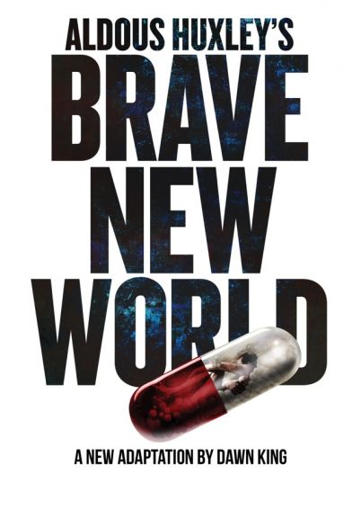
FOLLOW UP QUESTIONS

BRAVE NEW WORLD by Aldous Huxley

Overall
1. How do you know who you are? 2. Is this a utopia or a dystopia? What might this decision entail?
3. How is this related to E.M. Forster’s “The Machine Stops”? Modern Times?
4. What is so special about Ford or Freud?
5. At what price happiness?
6. What should be the goal of any society?
7. Who has power here?
8. How is stability maintained?
9. What role does the individual play in this society? How is that individual defined?
10. Who is the stability good for?
11. From whose point of view are we seeing this society?
12. What point of view does John represent?
13. Isn’t this “peace on earth and goodwill towards men”?
14. What would you be willing to give up for world peace, an end to poverty, hunger, etc.?
15. What would you consider to be a utopia?

“What is Happening to Our Population”
1. When did Huxley write this article?
2. How does a population vary “both in quality and quantity”? What is quality?
3. What is the ultimate aim of reformers? How does this figure in Brave New World?
4. How does Huxley propose the quality of the population be raised?
5. Which groups of people does he find desirable or undesirable?
6. Note he applauds the U.S., Canada, and Germany for their eugenic policies. When are we?
7. Why does he think some people oppose eugenics and/or sterilization?
8. How does he counter the argument of the “mystical democrats”?
9. What is your response to these arguments? Do you see related arguments today?
10. How does this relate to Brave New World?

“Science and Civilization”
1. When is this article written?
2. In science what is the difference between knowledge and application? What effect does this have?
3. What is Huxley’s utopian vision? His dystopian vision?
4. Is it better to “go wrong in freedom than to go right in chains?”
5. How is this all related to Brave New World?

Prologue
1. When is this prologue written? What important events have happened in this time?
2. How has Huxley’s view on his novel changed?
3. What other option would he give John?
4. Why is sanity a rare phenomenon?
5. What is science’s relation to humanity? Propaganda's?
6. How does Huxley see promiscuity in relation to freedom?
7. Why does he feel that we are drawing closer to his “Brave New World?”

